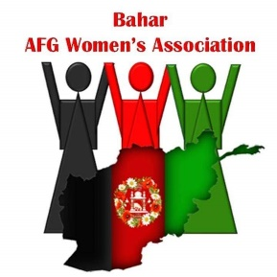

PARENTAL LIABILITY FORM

I, __________________________ , allow my child / children _______________________________ , to profit from the services provided by Bahar Women’s Association.
Therefore, I’m fully responsible of my child / children (at the Little London Community Centre) for any issues that occur to them / by them such as :
- Getting hurt;
- Getting sick;
- Getting lost;
- Getting into a fight with another child or staff member;
- Any other incidents.
I understand that if my child / children repeatedly disturb the classes, I’m responsible to handle it / to not bring them to the Little London Community Centre anymore.
I understand that Bahar Women’s Association does not provide nursery assistance at the Little London Community Centre for children over 1 years old.
I confirm that I have read the ‘Safeguarding’ and ‘Health and Safety’ policies accessible via the official website (http://www.baharwomen.org/policies-and-evaluation.html).
I agree to share my emergency contact details so that Bahar Women’s Association can get in touch in case of any incident.
------------------------------------------- Emergency contact information ------------------------------------------------
Name of guardian :
Phone number of guardian :
Email of guardian :
Name of GP and/or health visitor :
Phone number of GP and/or health visitor :
--------------------------------------------------------------------------------------------------------------------------------------

Name: BWA staff member:
Date: Date:
Signature: Signature:

